St Mary’s Star of the Sea Parish, 23 Parade Place, PO Box 69 Corowa 2646. Phone- 0260331927. Email: corowa@wagga.catholic.org.au Website: http//www.stmaryscorowa.com Wagga Wagga Safeguarding Office: safeguarding@wagga.catholic.edu.au Parish Safeguarding Officer-Roz Willett-0419015898:
Parish Priest -Fr John McGrath-St Mary’s School Principal-Cheryl Brigden-60331183: Parish toilets: located in presbytery adjacent to church.

Thank you to all who made last Sunday a special celebration for myself, family, parishioners and friends. I’ve had very positive responses from those who attended the Mass and the banquet afterwards in the school hall. The theme of banquet was expressed in the Sunday readings. We gathered as community and we celebrated at the Eucharist with the theme “Come with me into the fields’ and enjoyed the hospitality shared in the hall.
I thank all those who assisted in organising the function in the hall and the many who provided food. Thanks also to those who contributed a financial gift.
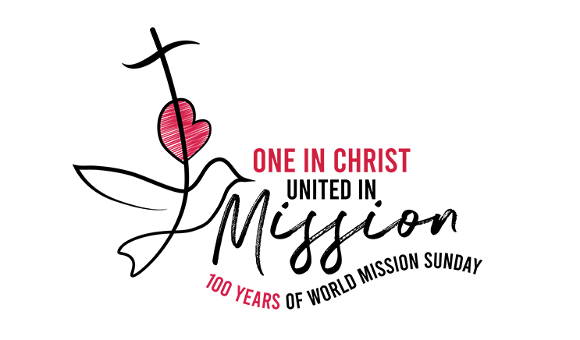

This year Pope Leo calls us to be “One in Christ, united in mission”, to be missionary disciples united in Christ and sent in love. Our annual mission appeal will be next weekend. Envelopes will be available in the church.
Mass Intentions
Remember in prayer:
Recently deceased: “We have loved them in life, let us not forget them in death.
May they live in God’s love forever.”
Marie Feehan (Yarrawonga), Gerald Dore (Urana), Michael Hickey(Wagga) Margaret Ryan (Melbourne) Marie Ford, Margaret O’Brien, Shirley Furlong (Howlong), Byron Carter, Shirley O’Brien, Roch McGrath (Tumbarumba), Jed Griffin
Anniversaries: Desmond Alexander (7/100 Frances Hanrahan (1/10) Mary Carter (27/9) Janina Palubiski (2/10)
Coreen Church
The pews at the church are on sale for $300 each. Please contact Fr John if you wish to purchase a pew. There are 5 pews remaining in the church.

The priests from the diocese will be on Retreat at Galong this week. This year is the non- compulsory year. Priests are available in Albury and Mulwala for emergencies.

**St Mary’s School will be holding their ART SHOW on the 6th, 7th and 8th November. Opening evening from 7pm-9pm. Complementary cheese, nibbles and drinks on the Friday night. Gold coin donations for other days. Saturday and Sunday 10am-2pm. Art works are for purchase and there will be an auction and raffle. All are welcome to support the school in the annual fundraiser.
Parish Diary
St Vincent de Paul Conference. Meeting on Oct 19th at 5pm at the Vinnie’s Centre
**Parish Rosary will be held at Nora Kingston’s at 24 Alfred St on Wednesday at 4.30. All welcome.
**Wrap with Love is in the parish hall on Mondays from 9am-12noon. All are welcome.
The Balldale Majellan Group meet this Wednesday at the NewmarketNe Hotel at 12.30. All welcome.

Parish Finances
Bank A/C s for St Mary’s parish. The presbytery is 206110498-BSB 066-789. The church is 206110290-BSB 066-789
*** We have a collection after the
Prayers of the Faithful. This collection supports the clergy of the diocese.
The support for the parish can be given through the envelope system, direct debit or tap and go.
** Another way to assist our parish is to consider a gift in your will.

Parish Safeguarding Commitment
St Mary’s Parish is committed to safeguarding and upholding the dignity and rights of all our children and vulnerable people. If any person has any concerns about the above, please contact the Parish Safeguarding Officer -Roz Willett 0419015898
Mass times
No masses this week-clergy retreat
Mon 19th No Mass at 9am
Tues 20th No Mass at 9am
Wed 21st No Mass at 9am
Thurs 22nd Novena at 11.4
No Communion Service
at 12noon
Fri 23rd No Mass at 9am
Sat 24th Mass at 6pm
Sun 25th Mass at 9am

Liturgy roster –Oct 17th-18th
Lectors
6pm Arthur Campbell
9am Brendan Christy
Special Ministers
6pm Terry Drum
9am Kate Roberts
Welcomers
6pm Volunteers
9am John Taylor/Brian O’Shea
Counters: Clergy Retreat
No counting

Liturgy roster –Oct 24th-25th
Lectors
6pm Annette Norman
9am Paul Lemmon
Special Ministers
6pm Ian Brooks
9am Angie Pilgrim
Welcomers
6pm Sandral Fm
9am Brian/Cathy O’Shea
Counters: Peter and Bernadette Ridge

