St Mary’s Star of the Sea Parish, 23 Parade Place, PO Box 69 Corowa 2646. Phone- 0260331927. Email: corowa@wagga.catholic.org.au Website: http//www.stmaryscorowa.com Wagga Wagga Safeguarding Office: safeguarding@wagga.catholic.edu.au Parish Safeguarding Officer-Roz Willett-0419015898:
Parish Priest -Fr John McGrath-St Mary’s School Principal-Cheryl Brigden-60331183: Country Church-St Pius X at Coreen
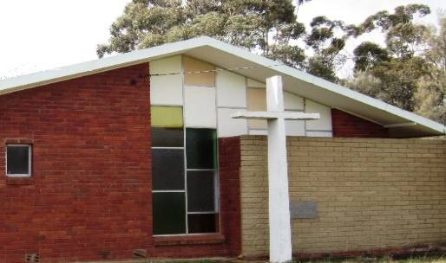
** Save the date for the closing of the Coreen Church. Bishop Mark will celebrate a final Mass on July 19th at 11.30. After the Mass on the 19th there will be a gathering at the Coreen Fire Station for a light luncheon. To assist with catering could you contact
Cathy Ross-0427358518
Kathryn McKenize-0408921051
Carmen Hanrahan-0437350277

There have been 2 weddings celebrated in the Coreen Church.
Thomas James Collins (son of Thomas John Collins and Mary Elizabeth Talbot) and Kathleen Therese Martin (daughter of John Henry Martin and Veronica Mary Carroll) were married on 10th February 1968. Fr Wilf Plunkett was the celebrant.
Geoffrey Roy King and Jeanette Mary Hanrahan (daughter of James Aloysius Hanrahan and Leslie Thelma Talbot) were married on 10th March 1979. Fr Doug George was the celebrant.

Mass Intentions
Remember in prayer:
Recently deceased: “We have loved them in life, let us not forget them in death.
May they live in God’s love forever.”
Brian Packer (Roma, Robert’s brother)
Anniversaries: Peter and Anne Carroll, Hugh Drum (14/6) Anne Aquilina (29/6)

Renewal prayer
God our Father
To praise and glorify you
We commit ourselves to the work of spiritual renewal.
Send your Holy Spirit on us all.
Refresh us with a new outpouring of love.
Form us into a true community of worship and love.
Deepen our understanding of your message today
Turn our hearts from selfishness and sin
To a life lived only for you and others.
May we learn the great message of Jesus:
“Love one another as I have loved you.”

“True progress always stems from a heart open to others,
an intelligence willing to listen
and a will that seeks what unites rather than what separates”
Pope Leo “The grandeur of humanity”
Parish Diary
St Vincent de Paul Conference. Meeting on July 6th at 5pm at the Vinnie’s Centre
**Parish Rosary will be held at Nora Kingston’s at 24 Alfred St on Wednesday at 4.30. All welcome.
**Wrap with Love is in the parish hall on Mondays from 9am-12noon. All are welcome.
** St Mary’s Court meeting this Thursday at 5pm.

Parish Finances
Bank A/C s for St Mary’s parish. The presbytery is 206110498-BSB 066-789. The church is 206110290-BSB 066-789
*** We have a collection after the
Prayers of the Faithful. This collection supports the clergy of the diocese.
The support for the parish can be given through the envelope system, direct debit or tap and go.
** Another way to assist our parish is to consider a gift in your will.

Parish Safeguarding Commitment
St Mary’s Parish is committed to safeguarding and upholding the dignity and rights of all our children and vulnerable people. If any person has any concerns about the above, please contact the Parish Safeguarding Officer -Roz Willett 0419015898

Mass times
Sun 5th Exposition of
the Blessed Sacrament
Benediction at 12.15
Mon 6th Mass at 9am
Tues 7th Mass at 9am
Wed 8th Mass at 9am
Thurs 9th Novena at 11.40
Mass at 12noon
Fri 10th Mass at 9am
Sat 11th Mass at 6pm
Sun 12th Mass at 9am

Liturgy roster –July 4th-5th
Lectors
6pm Sandra Drum
9am Mary Milthorpe
Special Ministers
6pm Jan Lowden
9am Paul Lemmon
Welcomers
6pm Volunteers
9am Brian and Cathy O’Shea
Counters Ian Brooks/Robert Packer

Liturgy roster –July 11th-12th
Lectors
6pm Ian Brooks
9am Audrey/Anna Mamvura
Special Ministers
6pm Annette Norman
9am Michael Nixon
Welcomers
6pm Sandral fm
9am John Taylor/Volunteer
Counters: Kevin and Trish Clissold

